Link Analysis:

This part of work is based on the links of stackoverflow and Russian stackoverflow. According to the previous results by some other similar research, links are good data to present the user activity and community activity.

Part 1: Links of Russian Stackoverflow:

Calculating the substring length can accurately count the number of all the links satisfying the requirement, even if there are more than one target string in a row. The result of the total links in Russian stackoverflow community is in figure 1, and the result for the compare between stackoverflow links and ru.stackoverflow links in Russian stackoverflow community is in figure 2.

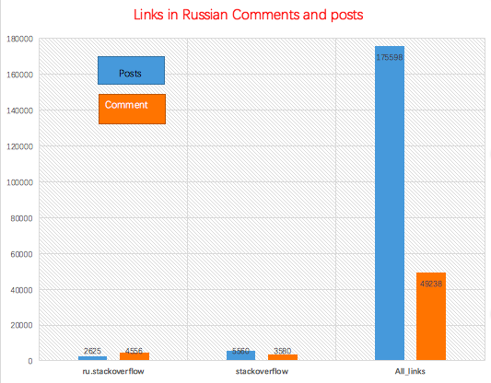

Figure

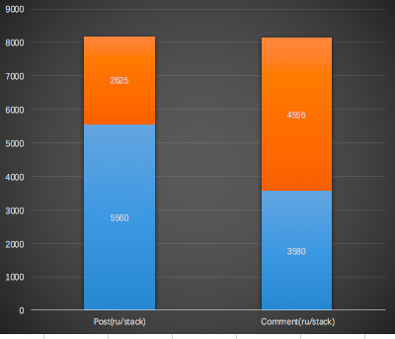

Figure

Part 2: Links of Stackoverflow:

Similarly, the statistics of links in stackoverflow community are in figure 3 and figure 4.

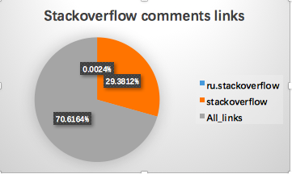

Figure

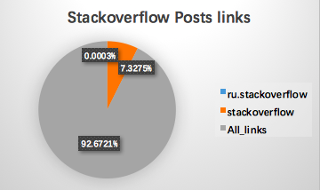

Figure

Part 3: The link connection between communities:

Combine these two parts of work, a clear connection between stackoverflow and Russian stackoverflow is represented in figure 5.

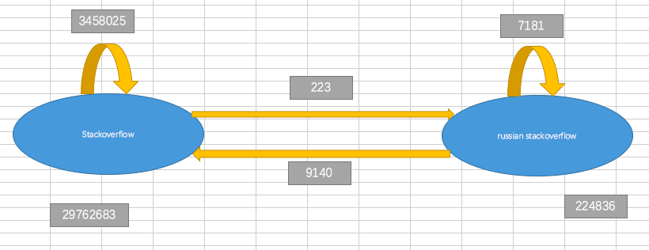

Figure